Behind the COVID-19 vaccination target: a SEIR simulation of avoidable deaths

Lucas Sempe[1]

Aravinda Guntupalli[2]

Peter Lloyd-Sherlock[3]

# 1 Introduction

A year after the launch of the COVID-19 vaccine immunisation process across countries, we note two facts. Vaccines have been proved very effective against existing variants of COVID-19 both in terms of preventing the acquisition of severe disease, hospitalisation and death; and also in terms of slowing down the spread of infections(Imai and Tanaka 2021).

Although the way out of the pandemics requires a worldwide solution, we note that the vaccine roll-out has been very inequality across countries. While many developed nations will have reached high vaccination coverages by the end of 2021 and before the upraise of the highly transmissible Omicron variant (Thakur et al. 2021), many low- and middle- income countries (LMICs) are still lagging in their vaccination process.

Until the vaccination coverage reaches the vast majority of the worldwide population, there will still be high uncertainty on the future development of the pandemics during the next years. Many factors may play a role as drivers of local or global outbreaks. Many countries have been already through more than one epidemic wave explained by factors such as the appearance of new variants or the easing of non-pharmaceutical interventions.

On 26 November 2021, the World Health Organization (WHO) designated the coronavirus SARS-CoV-2 B.1.1.529 a variant of concern, named Omicron Ferguson (2021a), although information is still limited to certain countries.

Considering the uncertainty of the upraise of Omicron, we simulate various scenarios to capture the potential magnitude on the number of deaths averted in the first semester of 2022 due to a potential vaccination raise towards fulfilling WHO’s goal. This uncertainty significantly increases in LMICs, where civil registration, vital statistics and epidemiological data is still not robust (Lloyd-Sherlock et al. 2020).

# 2 Empirical strategy

We simulated models based on a previously developed extended age-structured (5-year groups, where people over 80 are considered in one group) stochastic compartmental model of SARS-CoV-2 transmission that includes vaccinations (Hogan et al. 2021; Walker et al. 2020). The models considers the progression of the population across transmission compartments (susceptible, exposed, infected, recovered), clinical pathways (need for hospitalisation, oxygen and/or intensive care) and vaccination uptake considering factors such as vaccine availability, prioritisation and coverage. The infection transmission model also considers age-based contact matrices and the efficacy of the vaccine in terms of prevention of infection and severe disease.

SEIR models rely on an extensive set of parameters such as probabilities of hospitalisation, probability of severe disease, hospital capacity and ICU, reproduction rates, among others. Our simulated scenarios are built based on parameters chosen to represent critical factors affecting the evolution of the pandemics and the vaccination process.

We focus on the comparison between two scenarios for each country: a baseline scenario that reflects the daily average vaccination in the last month and a second scenario where the uptake of vaccines is raised to achieved the goal set by the World Health Organisation to vaccinate 70% of the world’s population against COVID-19 by 30 June 2022 (WHO 2021a). For the second scenario, we differentiate between countries that did not started providing boosters to their population and those who already started, even being behind WHO’s goal. In the first case, we simulate models with a daily number of vaccines needed to reach two dose for 70% of the population by June 30th, while in the second case, we increase the daily number of vaccines to cover three dose in the same period.

The comparison between those models provide our outcomes of interest: avoidable hospitalisations and deaths.

We model two different vaccination approaches. The first strategy prioritises sequentially the oldest age groups until a maximum set coverage is reached. For example, if we set the maximum coverage in 90%, the first age group to be solely vaccinated will be those over 85 years old until it reaches 90% of the age group population. Then, the following group, those aged 80 to 84 will follow on the vaccination process. This occurs until the whole eligible population is covered up to 90%. The second strategy does not prioritise any age groups and allows everyone to be vaccinated at the same time. This is consistent with an ongoing vaccination process in some countries where vaccines are offered simultaneously to the total adult population.

As more than 95% of the global procurement of vaccines require two dose vaccines , our models assume a fully vaccinated person with two vaccinesFerguson (2021b). These values do not reflect a specific vaccine as there are unknowns over each specific country vaccine roll out.

The probability of hospitalisation is reduced in 40% in comparison to the prior variants (Ferguson 2021c). We assume that the mean duration of vaccine and naturally acquired immunity goes beyond the number of days modelled. As we model countries without significant rates of vaccinations, we assume there is no existence of a third dose or booster to improve immunity.

We also simulate two set of starting number of infected cases: the officially reported number of cases of the last two weeks until 25 January 2022; this value is multiplied by 3, assuming the lack of massive testing and under-reporting of cases (Lau et al. 2021).

We use a constant effective reproduction number of 1.2 to 1.5, by .1 across the models time period (Wees et al. 2021; Huang et al. 2022; Ignatov and Trigger 2022). This assumes the pandemics is not suppressed during the first semester of 2022.

Recent evidence converge in showing the generation time for the Omicron variant is shorter than the previous predominant variant Delta (Abbott et al. 2022; Liu et al. 2021). Following that, we assume the following parameters: mean duration of 2 days for the incubation period, mean of 2.6 days for a mild infection and a mean of 3.8 days for symptoms onset to admission to hospital.

The time period for the analysis is from 26 January 2022 to 30 June 2022, which is set by the World Health Organisation as the limit to vaccinate 70% of the world’s population against COVID-19 (WHO 2021a).

Additional country-specific, epidemiological and vaccination parameters were compiled by Hogan et al (Hogan et al. 2021) and updated in the R package [‘nimue’](https://github.com/mrc-ide/nimue), where original sources of data are given. Infections and vaccine data are collected from Our World in Data (Roser et al. 2020). Additional parameters can be found in the Appendix.

# 3 Results

We find that, based on their last month vaccination uptake, 84 countries are behind WHO’s goal (see Figure 3.1) distributed across the world: 41 counties in Africa, 14 in the Americas, 12 in Asia, 10 in Europe and 7 in Oceania. 20 countries are small islands with a population less than 600,000 people each. Additionally, 19 of those countries already started to provide boosters to their population. See full list of countries in the Appendix.

Figure 3.2 shows that the gap between countries on track and those behind track is widening across the world. In all regions, we observe that the average of vaccination relative to the population is lower for the lagged countries.

Based on that, we estimate that at least two billion dose are needed to achieve the target of vaccinating 70% of these countries population. Considering a programmatic delivery cost of US$ 10 per dose (WHO 2021a), the estimation reaches twenty billion american dollars.

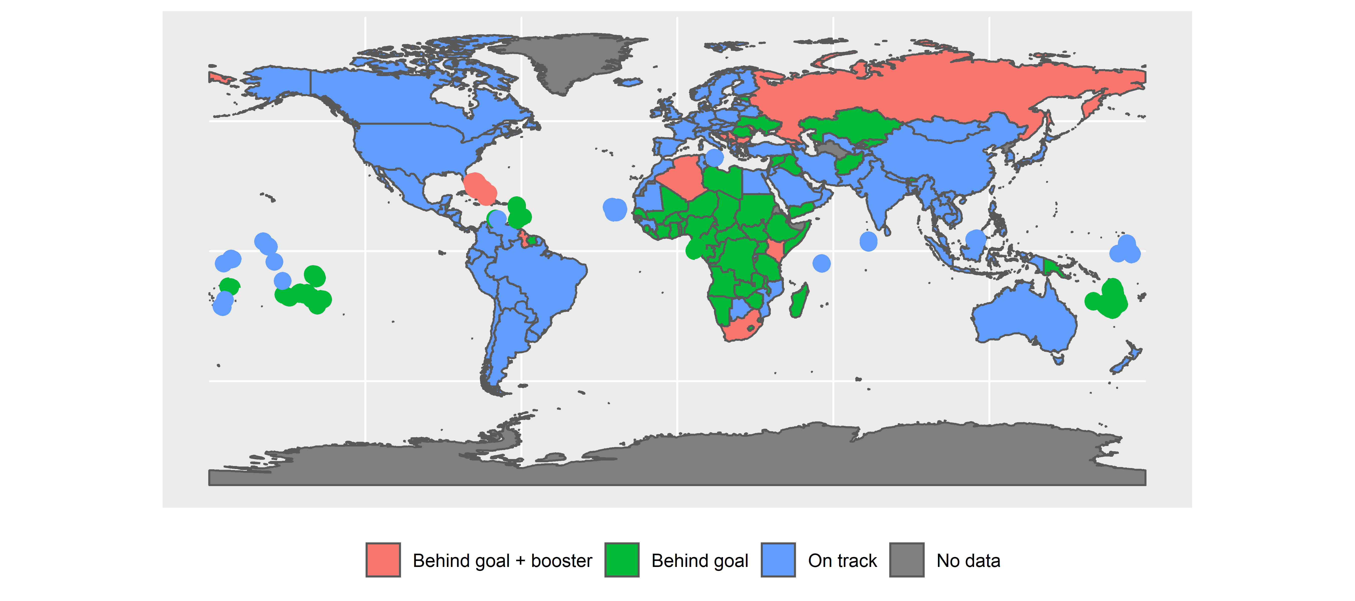

Figure 3.1: Countries behind WHO’s vaccination goal based on last month vaccination uptake

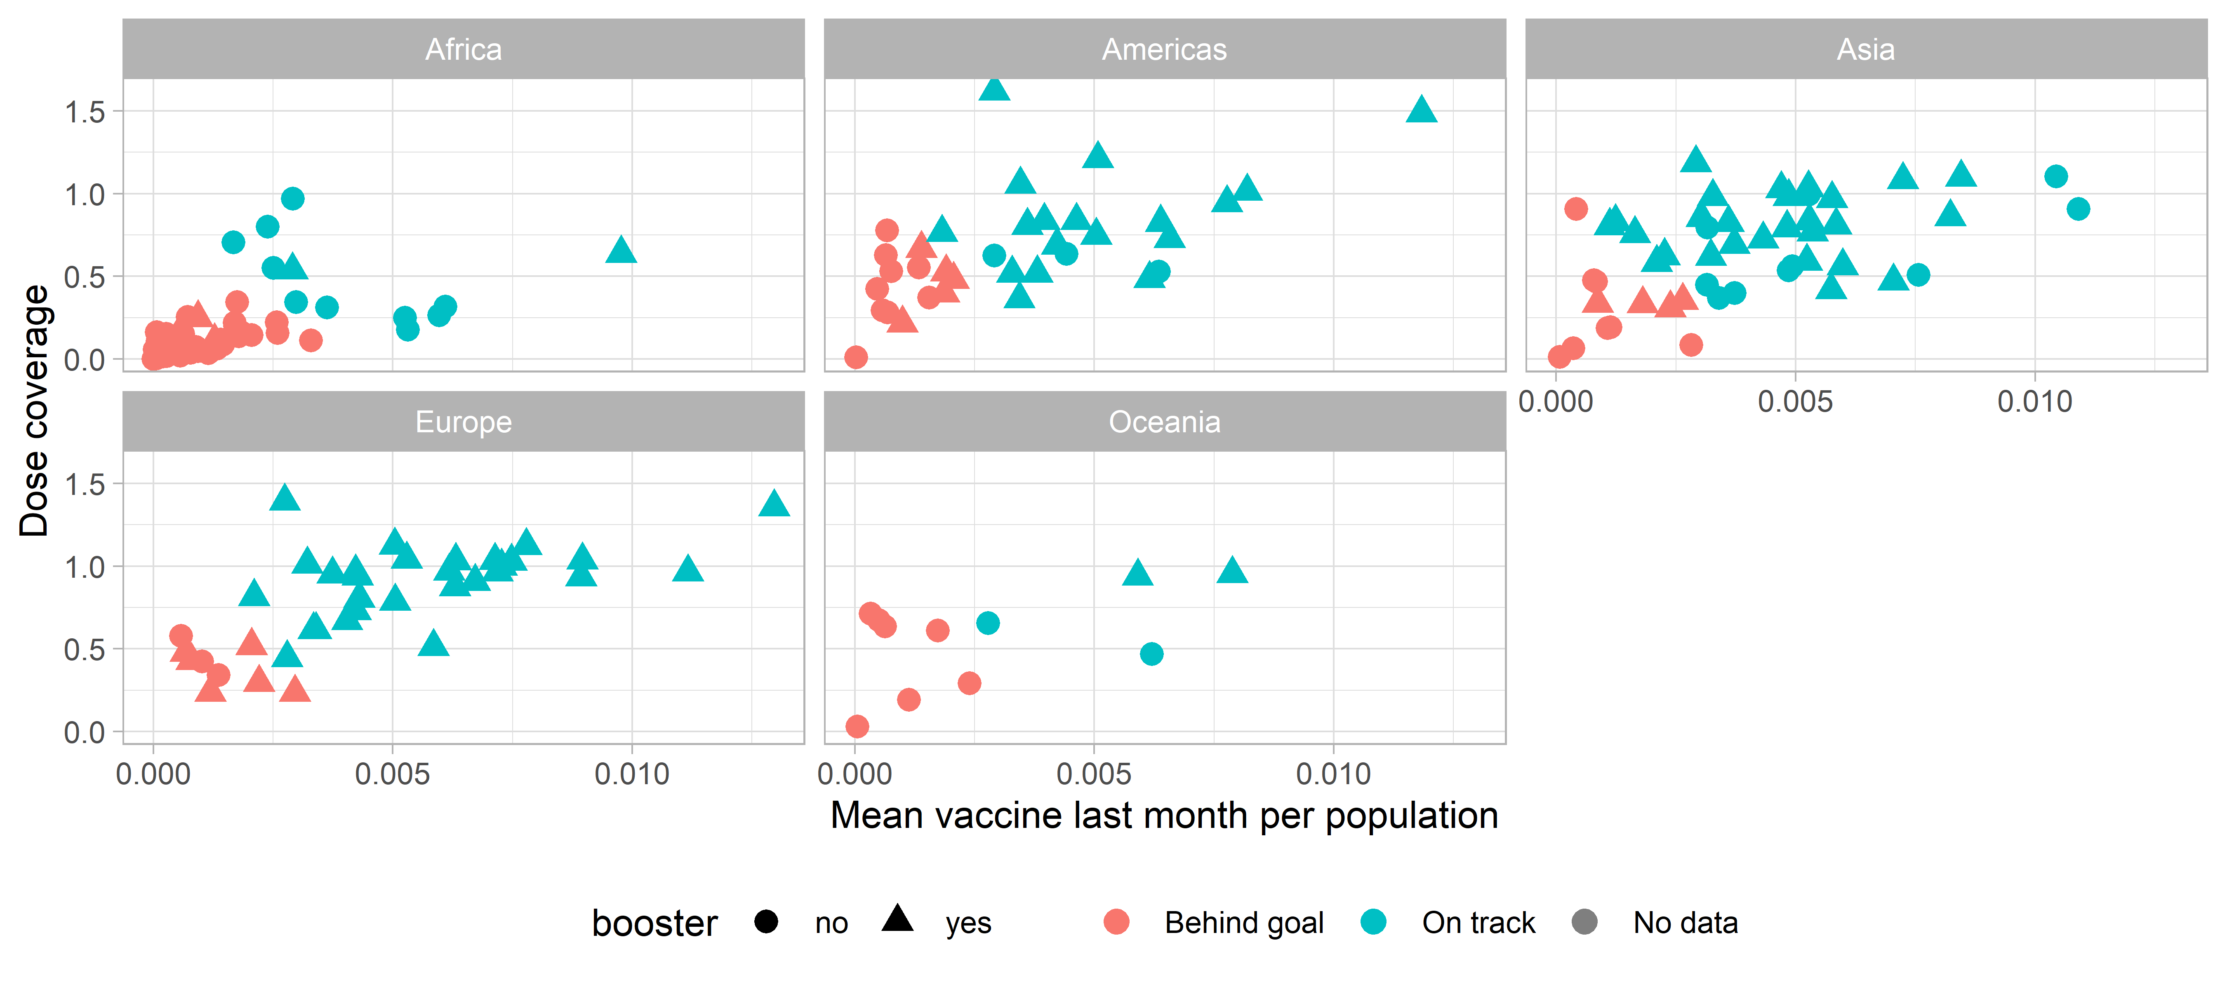

Figure 3.2: Last month vaccine uptake and dose coverage

The combination of the different model parameters provide 40 different scenarios for each country. Baseline models - based on the last month vaccination uptake- and the parameter R0 = 1.2 yield a range from 3e+05 to 5e+05deaths. Based on that, the estimation of avoidable deaths range from 72,873 to 116,205. Table @(tab:tb) shows the maximum and minimum number of averted deaths and hospitalisations computed across different R0. In the case of the scenarios of averted deaths, the differences between values do not change substantially when R is 1.3 or higher. In the case of the simulation of averted hospitalisations, the minimum values tend to be lower with higher reproduction numbers, which is explained by the full occupancy of ICU beds and the limit with the time period of the models.

| R0 | Max averted deaths | Min averted deaths | Max averted hospitalisations | Min averted hospitalisations |
| --- | --- | --- | --- | --- |
| 1.2 | 116,205 | 72,873 | 489,479 | 332,243 |
| 1.3 | 184,805 | 131,115 | 584,509 | 403,101 |
| 1.4 | 205,343 | 122,146 | 556,984 | 352,081 |
| 1.5 | 235,223 | 123,836 | 585,063 | 331,844 |

Across the vast majority countries, we find that the vaccination strategy that prioritises the older population should be chosen in terms of number of the magnitude of avoidable deaths. The magnitude of the positive effect increases with the R0. To exemplify differences across scenarios, Figure 3.3 presents the estimation of avoidable deaths across scenarios for Ethiopia, Algeria, South Africa and the Democratic Republic of Congo. They represent between 34% and 41% of the total estimated avertible deaths across scenarios. It is worth noticing that South Africa and Algeria are among those countries providing booster vaccinations although they are behind the WHO’s goal.

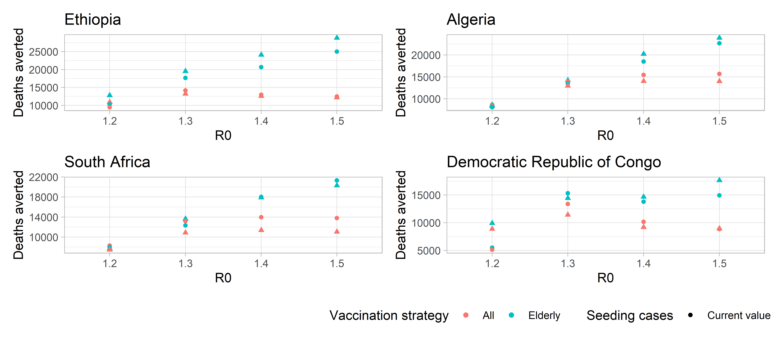

Figure 3.3: Deaths scenarios across scenarios - selected countries

Figure 3.4) shows that in the vast majority of models (represented by each point) between 60% and 70% of lives saved would correspond to people of 60 years old. This occurs even in majority of countries that currently portray a younger population age structure such cases of regions such as Africa and Asia.

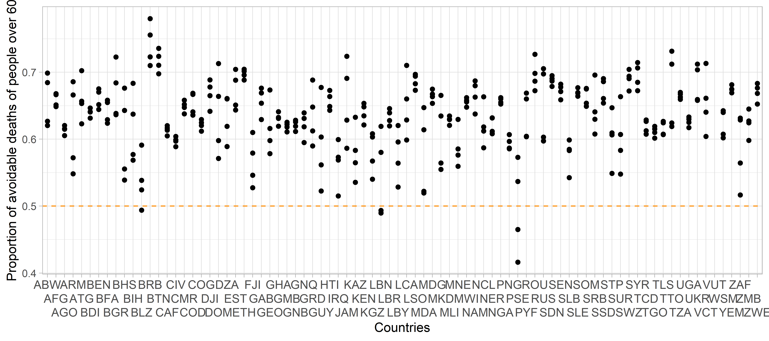

Figure 3.4: Proportion of avoidable deaths of older people across simulations

We perform two different set of robustness checks. First, we perform similar analysis using a 15-days average of vaccines, yielding very similar results in terms of the number of countries behind WHO’s goal.Additionally, we compare our SEIR models results with those presented by the Institute of Health Metrics and Evaluation

$$@ihme$$

and the MRC-IDE at Imperial College (MRC-IDE 2022). As expected, there are not significant differences between models, which are explained by the choice of different parameters.

# 4 Conclusions

These scenarios are built to answer to an ethical framework that aims to find the best possible allocation of COVID-19 vaccines. Our ethical guidelines are the following: we aim to maximise societal health benefits; prioritise those worst-off without the vaccines; and promote equality, where individuals under circumstances shall be treated equally (Persad, Peek, and Emanuel 2020; Emanuel et al. 2020). These principles become operational in terms of saving the most lives; prioritise the most vulnerable populations such as older and immunodeficient people; and protecting health workers.

Our simulations suggest that even with relatively low transmission rates, upraising daily vaccinations could save more than 100,000 lives in the analysed countries in the next few months. We also find that that, across all countries - even with different age-population structures - and across models using different parameters, results suggest consistently that older people account for the majority of averted deaths and hospitalisations.

As with any modelling study, we address several limitations. First, while vaccine efficacy parameters against infection and disease is proven for previous dominant variants, there is still not enough information to establish certain parameters. Estimates of hospitalisations and deaths may be inaccurate due to our working assumptions. However, the presented conterfactual analysis allows to measure the magnitude in terms of differences between vaccionation roll-outs.

# 5 References

Abbott, Sam, Katharine Sherratt, Moritz Gerstung, and Sebastian Funk. 2022. “Estimation of the Test to Test Distribution as a Proxy for Generation Interval Distribution for the Omicron Variant in England.” <http://dx.doi.org/10.1101/2022.01.08.22268920>.

Collie, Shirley, Jared Champion, Harry Moultrie, Linda-Gail Bekker, and Glenda Gray. 2021. “Effectiveness of BNT162b2 Vaccine Against Omicron Variant in South Africa.” *New England Journal of Medicine*, December. <https://doi.org/10.1056/nejmc2119270>.

Emanuel, Ezekiel J., Govind Persad, Adam Kern, Allen Buchanan, Cécile Fabre, Daniel Halliday, Joseph Heath, et al. 2020. “An Ethical Framework for Global Vaccine Allocation.” *Science* 369 (6509): 1309–12. <https://doi.org/10.1126/science.abe2803>.

Ferguson, N. 2021b. “Report 49: Growth and Immune Escape of the Omicron SARS-CoV-2 Variant of Concern in England.” Imperial College London. <https://doi.org/10.25561/93038>.

———. 2021a. “Report 49: Growth and Immune Escape of the Omicron SARS-CoV-2 Variant of Concern in England.” <https://doi.org/10.25561/93038>.

———. 2021c. “Report 50: Effectiveness of SARS-CoV-2 Vaccines in England in 2021: A Whole Population Survival Analysis.” Imperial College London. <https://doi.org/10.25561/93035>.

Hogan, Alexandra B., Peter Winskill, Oliver J. Watson, Patrick G. T. Walker, Charles Whittaker, Marc Baguelin, Nicholas F. Brazeau, et al. 2021. “Within-Country Age-Based Prioritisation, Global Allocation, and Public Health Impact of a Vaccine Against SARS-CoV-2: A Mathematical Modelling Analysis.” *Vaccine* 39 (22): 2995–3006. <https://doi.org/10.1016/j.vaccine.2021.04.002>.

Huang, Jianping, Yingjie Zhao, Li Zhang, Xu Li, Shuoyuan Gao, and Xiaodong Song. 2022. “Seasonal Prediction of Omicron Pandemic.” <http://dx.doi.org/10.1101/2022.01.13.22269198>.

Ignatov, A. M., and S. A. Trigger. 2022. “Two Viruses Competition in the SIR Model of Epidemic Spread: Application to COVID-19.” <http://dx.doi.org/10.1101/2022.01.11.22269046>.

Imai, Kenichi, and Hajime Tanaka. 2021. “SARS-CoV-2 Infection and Significance of Oral Health Management in the Era of “the New Normal with COVID-19”.” *International Journal of Molecular Sciences* 22 (12): 6527. <https://doi.org/10.3390/ijms22126527>.

IMF-WHO. 2022. “IMF-WHO COVID-19 Vaccine Tracker.” <https://www.imf.org/en/Topics/imf-and-covid19/IMF-WHO-COVID-19-Vaccine-Tracker>.

Khoury, David S., Megan Steain, James A. Triccas, Alex Sigal, Miles P. Davenport, and Deborah Cromer. 2021. “A Meta-Analysis of Early Results to Predict Vaccine Efficacy Against Omicron.” <http://dx.doi.org/10.1101/2021.12.13.21267748>.

Lau, H., T. Khosrawipour, P. Kocbach, H. Ichii, J. Bania, and V. Khosrawipour. 2021. “Evaluating the Massive Underreporting and Undertesting of COVID-19 Cases in Multiple Global Epicenters.” *Pulmonology* 27 (2): 110–15. <https://doi.org/10.1016/j.pulmoe.2020.05.015>.

Liu, Lihong, Sho Iketani, Yicheng Guo, Jasper F-W. Chan, Maple Wang, Liyuan Liu, Yang Luo, et al. 2021. “Striking Antibody Evasion Manifested by the Omicron Variant of SARS-CoV-2.” *Nature*, December. <https://doi.org/10.1038/s41586-021-04388-0>.

Lloyd-Sherlock, Peter, Lucas Sempe, Martin McKee, and Aravinda Guntupalli. 2020. “Problems of Data Availability and Quality for COVID-19 and Older People in Low- and Middle-Income Countries.” Edited by Suzanne Meeks. *The Gerontologist* 61 (2): 141–44. <https://doi.org/10.1093/geront/gnaa153>.

Meng, Bo, Isabella A. T. M. Ferreira, Adam Abdullahi, Akatsuki Saito, Izumi Kimura, Daichi Yamasoba, Steven A. Kemp, et al. 2021. “SARS-CoV-2 Omicron Spike Mediated Immune Escape, Infectivity and Cell-Cell Fusion.” <https://www.biorxiv.org/content/10.1101/2021.12.17.473248v2>.

MRC-IDE. 2022. “Imperial College COVID-19 LMIC Reports.” <https://mrc-ide.github.io/global-lmic-reports/>.

Persad, Govind, Monica E. Peek, and Ezekiel J. Emanuel. 2020. “Fairly Prioritizing Groups for Access to COVID-19 Vaccines.” *JAMA* 324 (16): 1601. <https://doi.org/10.1001/jama.2020.18513>.

“Report 12 - the Global Impact of COVID-19 and Strategies for Mitigation and Suppression.” n.d. <http://www.imperial.ac.uk/medicine/departments/school-public-health/infectious-disease-epidemiology/mrc-global-infectious-disease-analysis/covid-19/report-12-global-impact-covid-19/>.

Roser, Max, Hannah Ritchie, Esteban Ortiz-Ospina, and Joe Hasell. 2020. “Coronavirus Pandemic (COVID-19).” *Our World in Data*.

Thakur, Amrit Kumar, Ravishankar Sathyamurthy, Velraj Ramalingam, Iseult Lynch, Swellam Wafa Sharshir, Zhenjun Ma, Ganeshkumar Poongavanam, Suyeong Lee, Yeseul Jeong, and Jang-Yeon Hwang. 2021. “A Case Study of SARS-CoV-2 Transmission Behavior in a Severely Air-Polluted City (Delhi, India) and the Potential Usage of Graphene Based Materials for Filtering Air-Pollutants and Controlling/Monitoring the COVID-19 Pandemic.” *Environmental Science: Processes & Impacts*. <https://doi.org/10.1039/d1em00034a>.

Walker, Patrick G. T., Charles Whittaker, Oliver J. Watson, Marc Baguelin, Peter Winskill, Arran Hamlet, Bimandra A. Djafaara, et al. 2020. “The Impact of COVID-19 and Strategies for Mitigation and Suppression in Low- and Middle-Income Countries.” *Science* 369 (6502): 413–22. <https://doi.org/10.1126/science.abc0035>.

Wees, Jan-Diederik van, Martijn van der Kuip, Sander Osinga, Bart Keijser, David van Westerloo, Maurice Hanegraaf, Maarten Pluymaekers, Olwijn Leeuwenburgh, Logan Brunner, and Marceline Tutu van Furth. 2021. “SIR Model for Assessing the Impact of the Advent of Omicron and Mitigating Measures on Infection Pressure and Hospitalization Needs.” <http://dx.doi.org/10.1101/2021.12.25.21268394>.

WHO. 2021a. “Strategy to Achieve Global Covid-19 Vaccination by Mid-2022.” World Health Organisation.

———. 2021b. “Update on Omicron.” 2021. <https://www.who.int/news/item/28-11-2021-update-on-omicron>.

———. 2022. “COVID-19 Vaccination Data.” <https://app.powerbi.com/view?r=eyJrIjoiMWNjNzZkNjctZTNiNy00YmMzLTkxZjQtNmJiZDM2MTYxNzEwIiwidCI6ImY2MTBjMGI3LWJkMjQtNGIzOS04MTBiLTNkYzI4MGFmYjU5MCIsImMiOjh9>.

# 6 Appendix

## 6.1 Countries behing WHO’s vaccination goal

| iso_a3 | current_coverate | vaccines_per_day_needed | average_vac_month | population | total_vaccines | booster |
| --- | --- | --- | --- | --- | --- | --- |
| AFG | 0.06526 | 50,129 | 13,999 | 3.9e+07 | 5081064 | no |
| DZA | 0.14794 | 75,194 | 22,589 | 4.4e+07 | 12974545 | yes |
| AGO | 0.22194 | 50,129 | 84,776 | 3.3e+07 | 14588435 | no |
| ATG | 0.62828 | 50,129 | 64 | 9.8e+04 | 123051 | no |
| ARM | 0.30801 | 75,194 | 7,058 | 3.0e+06 | 1825382 | yes |
| ABW | 0.77743 | 50,129 | 72 | 1.1e+05 | 166004 | no |
| BHS | 0.39777 | 75,194 | 732 | 3.9e+05 | 312840 | yes |
| BRB | 0.52995 | 50,129 | 220 | 2.9e+05 | 304582 | no |
| BLZ | 0.55354 | 50,129 | 531 | 4.0e+05 | 440194 | no |
| BEN | 0.08819 | 50,129 | 17,688 | 1.2e+07 | 2138322 | no |
| BTN | 0.90759 | 50,129 | 320 | 7.7e+05 | 1400608 | no |
| BIH | 0.23681 | 75,194 | 9,695 | 3.3e+06 | 1553874 | yes |
| BGR | 0.29610 | 75,194 | 15,306 | 6.9e+06 | 4114896 | yes |
| BFA | 0.03012 | 50,129 | 9,788 | 2.1e+07 | 1259250 | no |
| BDI | 0.00035 | 50,129 | 45 | 1.2e+07 | 8400 | no |
| CMR | 0.01929 | 50,129 | 991 | 2.7e+07 | 1024333 | no |
| CAF | 0.06253 | 50,129 | 3,488 | 4.8e+06 | 603963 | no |
| TCD | 0.01141 | 50,129 | 2,544 | 1.6e+07 | 374952 | no |
| CIV | 0.14389 | 50,129 | 54,093 | 2.6e+07 | 7591109 | no |
| COD | 0.00255 | 50,129 | 4,398 | 9.0e+07 | 457160 | no |
| DJI | 0.07448 | 50,129 | 608 | 9.9e+05 | 147166 | no |
| DOM | 0.66770 | 75,194 | 15,053 | 1.1e+07 | 14486398 | yes |
| GNQ | 0.16239 | 50,129 | 102 | 1.4e+06 | 455655 | no |
| EST | 0.57849 | 50,129 | 764 | 1.3e+06 | 1534776 | no |
| SWZ | 0.19939 | 50,129 | 1,981 | 1.2e+06 | 462652 | no |
| ETH | 0.04772 | 50,129 | 6,650 | 1.1e+08 | 10973077 | no |
| FJI | 0.71247 | 50,129 | 294 | 9.0e+05 | 1277372 | no |
| PYF | 0.61104 | 50,129 | 487 | 2.8e+05 | 343287 | no |
| GAB | 0.11660 | 50,129 | 3,128 | 2.2e+06 | 519058 | no |
| GMB | 0.07239 | 50,129 | 2,142 | 2.4e+06 | 349875 | no |
| GEO | 0.33438 | 75,194 | 7,204 | 4.0e+06 | 2667808 | yes |
| GHA | 0.15681 | 50,129 | 80,448 | 3.1e+07 | 9745332 | no |
| GRD | 0.37026 | 50,129 | 175 | 1.1e+05 | 83322 | no |
| GNB | 0.10757 | 50,129 | 170 | 2.0e+06 | 423400 | no |
| GUY | 0.48151 | 75,194 | 1,623 | 7.9e+05 | 757464 | yes |
| HTI | 0.00898 | 50,129 | 326 | 1.1e+07 | 204902 | no |
| IRQ | 0.19308 | 50,129 | 45,630 | 4.0e+07 | 15532626 | no |
| JAM | 0.21749 | 75,194 | 2,932 | 3.0e+06 | 1288073 | yes |
| KAZ | 0.47504 | 50,129 | 14,792 | 1.9e+07 | 17839238 | no |
| KEN | 0.11027 | 75,194 | 68,554 | 5.4e+07 | 11858964 | yes |
| KGZ | 0.18714 | 50,129 | 6,986 | 6.5e+06 | 2441934 | no |
| LBN | 0.35355 | 75,194 | 18,041 | 6.8e+06 | 4826318 | yes |
| LSO | 0.16300 | 50,129 | 3,932 | 2.1e+06 | 698383 | no |
| LBR | 0.11338 | 50,129 | 16,662 | 5.1e+06 | 1146910 | no |
| LBY | 0.21856 | 50,129 | 11,687 | 6.9e+06 | 3003536 | no |
| MDG | 0.01754 | 50,129 | 7,645 | 2.8e+07 | 971426 | no |
| MWI | 0.04967 | 50,129 | 5,282 | 1.9e+07 | 1900351 | no |
| MLI | 0.03480 | 50,129 | 23,185 | 2.0e+07 | 1409266 | no |
| MDA | 0.23553 | 75,194 | 4,797 | 4.0e+06 | 1900228 | yes |
| MNE | 0.51842 | 75,194 | 1,287 | 6.3e+05 | 651205 | yes |
| NAM | 0.15225 | 50,129 | 690 | 2.5e+06 | 773702 | no |
| NCL | 0.63416 | 50,129 | 180 | 2.9e+05 | 362095 | no |
| NER | 0.03673 | 50,129 | 18,757 | 2.4e+07 | 1778173 | no |
| NGA | 0.04741 | 50,129 | 191,980 | 2.1e+08 | 19546558 | no |
| MKD | 0.42934 | 75,194 | 1,653 | 2.1e+06 | 1788943 | yes |
| PNG | 0.02917 | 50,129 | 476 | 8.9e+06 | 521934 | no |
| COG | 0.06876 | 50,129 | 3,831 | 5.5e+06 | 758891 | no |
| ROU | 0.42427 | 50,129 | 19,517 | 1.9e+07 | 16323909 | no |
| RUS | 0.52055 | 75,194 | 298,655 | 1.5e+08 | 151930977 | yes |
| WSM | 0.67289 | 50,129 | 100 | 2.0e+05 | 267016 | no |
| STP | 0.34459 | 50,129 | 384 | 2.2e+05 | 151040 | no |
| SEN | 0.05745 | 50,129 | 459 | 1.7e+07 | 1923773 | no |
| SRB | 0.47907 | 75,194 | 5,876 | 8.7e+06 | 8371669 | yes |
| SLE | 0.08834 | 50,129 | 1,199 | 8.0e+06 | 1409313 | no |
| SLB | 0.19224 | 50,129 | 778 | 6.9e+05 | 264085 | no |
| SOM | 0.05067 | 50,129 | 6,549 | 1.6e+07 | 1610500 | no |
| ZAF | 0.24830 | 75,194 | 54,968 | 5.9e+07 | 29452653 | yes |
| SSD | 0.01423 | 50,129 | 1,281 | 1.1e+07 | 318565 | no |
| LCA | 0.29291 | 50,129 | 107 | 1.8e+05 | 107573 | no |
| VCT | 0.28080 | 50,129 | 76 | 1.1e+05 | 62308 | no |
| PSE | 0.33573 | 75,194 | 4,431 | 5.1e+06 | 3425379 | yes |
| SDN | 0.04240 | 50,129 | 9,356 | 4.4e+07 | 3718299 | no |
| SUR | 0.42296 | 50,129 | 276 | 5.9e+05 | 496244 | no |
| SYR | 0.08498 | 50,129 | 49,383 | 1.8e+07 | 2974507 | no |
| TZA | 0.02035 | 50,129 | 33,284 | 6.0e+07 | 2431769 | no |
| TLS | 0.46937 | 50,129 | 1,095 | 1.3e+06 | 1237678 | no |
| TGO | 0.15192 | 50,129 | 5,150 | 8.3e+06 | 2515341 | no |
| TTO | 0.52522 | 75,194 | 2,667 | 1.4e+06 | 1470094 | yes |
| UGA | 0.13773 | 50,129 | 81,580 | 4.6e+07 | 12599741 | no |
| UKR | 0.33999 | 50,129 | 59,434 | 4.4e+07 | 29738170 | no |
| VUT | 0.29052 | 50,129 | 736 | 3.1e+05 | 178464 | no |
| YEM | 0.01228 | 50,129 | 2,072 | 3.0e+07 | 732786 | no |
| ZMB | 0.06271 | 50,129 | 24,398 | 1.8e+07 | 2305684 | no |
| ZWE | 0.25317 | 50,129 | 10,667 | 1.5e+07 | 7525574 | no |

## 6.2 Number of doses for ountries behing WHO’s vaccination goal

| country | vaccine_dose_needed |
| --- | --- |
| Afghanistan | 4.9e+07 |
| Algeria | 7.7e+07 |
| Angola | 3.5e+07 |
| Antigua and Barbuda | 5.0e+04 |
| Armenia | 4.2e+06 |
| Aruba | 3.3e+04 |
| Bahamas | 4.9e+05 |
| Barbados | 1.9e+05 |
| Belize | 2.4e+05 |
| Benin | 1.5e+07 |
| Bhutan | 9.9e+04 |
| Bosnia and Herzegovina | 5.2e+06 |
| Bulgaria | 1.0e+07 |
| Burkina Faso | 2.7e+07 |
| Burundi | 1.6e+07 |
| Cameroon | 3.5e+07 |
| Central African Republic | 6.2e+06 |
| Chad | 2.2e+07 |
| Cote d'Ivoire | 3.1e+07 |
| Democratic Republic of Congo | 1.2e+08 |
| Djibouti | 1.3e+06 |
| Dominican Republic | 7.5e+06 |
| Equatorial Guinea | 1.6e+06 |
| Estonia | 7.7e+05 |
| Eswatini | 1.3e+06 |
| Ethiopia | 1.5e+08 |
| Fiji | 3.6e+05 |
| French Polynesia | 1.5e+05 |
| Gabon | 2.7e+06 |
| Gambia | 3.0e+06 |
| Georgia | 5.5e+06 |
| Ghana | 3.6e+07 |
| Grenada | 9.8e+04 |
| Guinea-Bissau | 2.4e+06 |
| Guyana | 8.4e+05 |
| Haiti | 1.5e+07 |
| Iraq | 4.4e+07 |
| Jamaica | 4.8e+06 |
| Kazakhstan | 1.4e+07 |
| Kenya | 9.6e+07 |
| Kyrgyz Republic | 7.3e+06 |
| Lebanon | 9.1e+06 |
| Lesotho | 2.5e+06 |
| Liberia | 6.1e+06 |
| Libya | 7.4e+06 |
| Madagascar | 3.7e+07 |
| Malawi | 2.5e+07 |
| Mali | 2.7e+07 |
| Moldova | 6.4e+06 |
| Montenegro | 6.3e+05 |
| Namibia | 2.9e+06 |
| New Caledonia | 1.4e+05 |
| Niger | 3.2e+07 |
| Nigeria | 2.7e+08 |
| North Macedonia | 2.5e+06 |
| Papua New Guinea | 1.2e+07 |
| Republic of the Congo | 7.0e+06 |
| Romania | 1.5e+07 |
| Russia | 1.5e+08 |
| Samoa | 9.0e+04 |
| Sao Tome and Principe | 2.0e+05 |
| Senegal | 2.1e+07 |
| Serbia | 9.4e+06 |
| Sierra Leone | 9.9e+06 |
| Solomon Islands | 7.6e+05 |
| Somalia | 2.1e+07 |
| South Africa | 9.2e+07 |
| South Sudan | 1.5e+07 |
| St. Lucia | 1.8e+05 |
| St. Vincent and the Grenadines | 1.1e+05 |
| State of Palestine | 6.9e+06 |
| Sudan | 5.7e+07 |
| Suriname | 4.7e+05 |
| Syria | 2.2e+07 |
| Tanzania | 7.9e+07 |
| Timor-Leste | 9.6e+05 |
| Togo | 9.6e+06 |
| Trinidad and Tobago | 1.4e+06 |
| Uganda | 5.3e+07 |
| Ukraine | 4.0e+07 |
| Vanuatu | 3.0e+05 |
| Yemen | 4.0e+07 |
| Zambia | 2.3e+07 |
| Zimbabwe | 1.5e+07 |

1. Institute of Global Health and Development, Queen Margareth
2. Institute of Applied Health Sciences, School of Medicine, Medical Sciences and Nutrition, University of Aberdeen
3. School of International Development, University of East Anglia